Single Family Property Bed, 2 Bath $250,500 $1,130 Per Month (5.4394%, 30yr 20% [$50,100] down)
- Area: Phoenix
- Subdivision: MARLBOROUGH COUNTRY METRO
- Year Built: 1978
- 4 total bedroom(s)
- 2 total bath(s)
- Type: Detached home
- Fireplace(s)
- Swimming pool(s)
- Spa/hot tub(s)
- 2 car garage
- Heating features: Electric
- Central air conditioning
- Interior features: Double sinks in master bathroom, Master bathroom, Ceiling fan(s), Vaulted ceiling(s), Eat-in kitchen, Dishwasher, Disposal, Range and oven, Great room
- Exterior features: Auto watering system, Patio, Block fencing/wall(s), Fee simple, Diving board, Private swimming pool, Desert back property, North/South exposure, Lanai, Public sewer service, 1601-1800 sq. ft., City water supply, Elementary School District: 6, High School District: 205, Private spa/hot tub
- Roofing: Composition
- Elementary School: Tumbleweed
- Jr. High School: Cholla
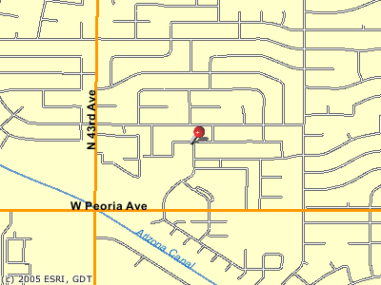
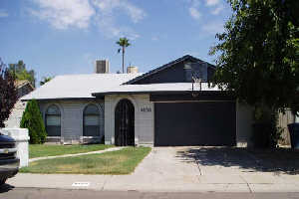
- 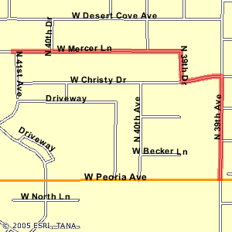High School: Moon Valley

